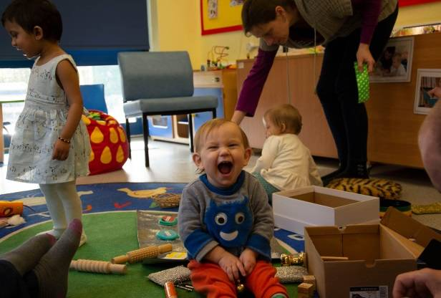
Family Learning ‘Starting School’ sessions
Fantastic FREE sessions to help parents and carers with children use to start in Reception in September 2023. Visit our website and search for the course code below to book a place - www.norfolk.gov.uk/education-and-learning/adult-learning

Course code | Course title | Start date | Start time | End time |  | Day |  | Location
FLETS0922P | Starting School | 16/06/2023 | 10.00am |  | 11.30am |  | Fri |  | Wymondham library
FLETS1022P | Starting School | 16/06/2023 | 1.00pm |  | 2.30pm |  | Fri |  | Hethersett library
FLETS0422P | Starting School | 22/06/2023 | 9.30am |  | 11.00am |  | Thurs |  | Long Stratton ECFS Base
FLETL0522P | Starting School | 22/06/2023 | 1.00pm |  | 2.30pm |  | Thurs |  | ONLINE
FLETB0322P | Starting School | 22/06/2023 | 10.00am |  | 11.30am |  | Thurs |  | Dereham library
FLETL0622P | Starting School | 23/06/2023 | 9.30am |  | 11.00am |  | Fri |  | ONLINE
FLETB0422P | Starting School | 29/06/2023 | 9.30am |  | 11.00am |  | Thurs |  | Attleborough Community & Enterprise Centre
FLETB0522P | Starting School | 13/07/2023 | 10.00am |  | 11.30am |  | Thurs |  | Dereham library
FLETS1122P | Starting School | 13/07/2023 | 9.30am |  | 11.00am |  | Thurs |  | Long Stratton ECFS Base
FLETL0722P | Starting School | 14/07/2023 | 1.00pm |  | 2.30pm |  | Fri |  | ONLINE

