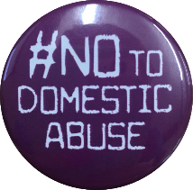
Domestic Abuse Champions Training
(Free Training!!!)

When:
- 20th & 27th May 2021
OR
- 15th & 17th June 2021

Where: Online via Microsoft Teams

From: 10am-5pm

Request to book: da.change@norfolk.gov.uk (no cost attached)

- Be the key domestic abuse contact for your agency
- Disseminate up to date information about domestic abuse to your team
- Raise awareness in your organisation
- Be the link between your organisation and the Champions Network

- Free two-day training
- Access to advice and consultancy
- Regular Network Events and DA News Updates
Day Two
Workplace Domestic Abuse Policy
Encouraging Disclosures
Responding to Disclosures
DASH Risk Assessment
Supporting Children and Young People
Safety Planning
Local Support Agencies

Day One
What is Domestic Abuse?
The Dynamics of Power and Control
The Impact of Domestic Abuse
Barriers to Leaving
The Impact on Children
Honour Based Abuse, Forced Marriage, and Female Genital Mutilation

